Soybean Sort

Number each picture in order of the plant’s life cycle. Then, label each picture using the word bank below.

Seed Seedling Germination Flowering

Growing Plant Mature Pod Green Pod

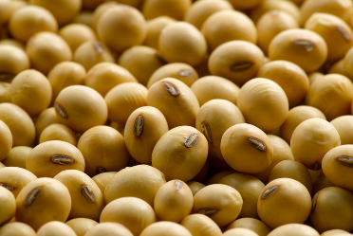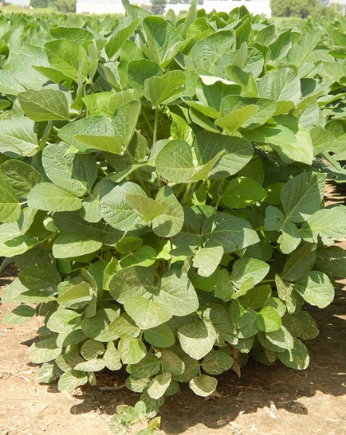

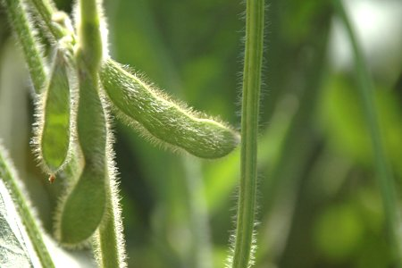[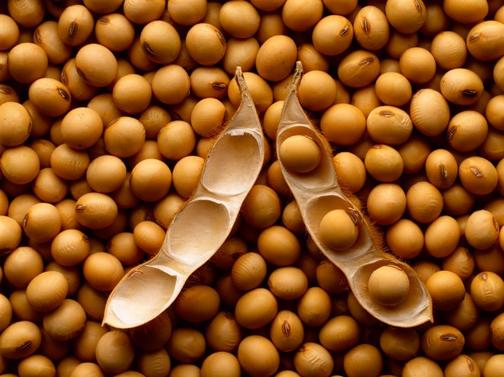](http://www.google.com/url?sa=i&rct=j&q=&esrc=s&source=images&cd=&cad=rja&uact=8&ved=0ahUKEwiDs8mHgp3RAhUGQiYKHfRHA2AQjRwIBw&url=http://www.arvglobaltrading.com/product/mature-soybean/&bvm=bv.142059868,d.eWE&psig=AFQjCNGIFSaXSm20G3eI6LfRSa60-_y3nQ&ust=1483225048555680)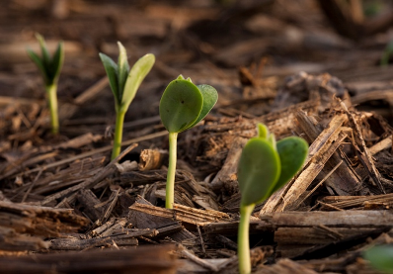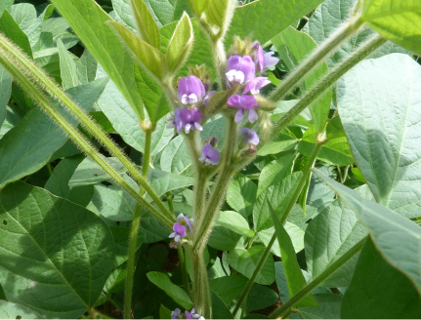

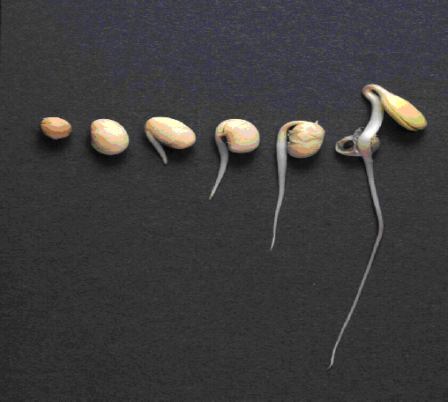



Using what you learned, write at least three complete sentences about the soybean lifecycle.

1. ________________________________________________________________________________________________________________________________________________________________________________________________
2. ________________________________________________________________________________________________________________________________________________________________________________________________
3. ________________________________________________________________________________________________________________________________________________________________________________________________